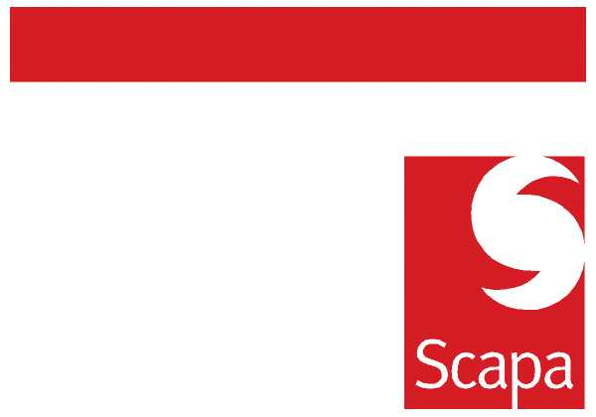

11 January 2011

Launch of Integrated Risk Management System

This week we have commenced the rollout of the Group’s new intranet based Integrated Risk Management System (IRMS).
Some of you will already be familiar with the existing Risk Suite and Tracker systems which are used to record the Group’s risk profiles and the status of related management actions. Both of these systems will be replaced by IRMS.
IRMS has also been designed to incorporate, enhance and standardise core elements of Scapa’s Environment, Health & Safety (E H & S) Management processes. Improvement in this area is an Executive priority.
The initial system will support:
- All Risk Assessment, including EH & S Risks and Hazards
- Accident Reporting
- Near Miss/Incident/Safety Opportunities
- All Action Tracking
- Dashboard reporting, including Accident trend analysis
E H & S functionality is being piloted at Renfrew, followed by implementations at other sites to a timetable to be determined. Existing Risk Profiles and Actions on Risk Suite and Tracker will be loaded to IRMS over the next few days. Site Managers and impacted users will be contacted as required to meet training needs.
If you have any questions please contact Andrew Monkhouse, Group Risk and Assurance Manager.

Paul Edwards Ian Marchant
Group Finance Director Group Operations Director

